**EXPERIMENT 10:**

Create a simple cloud software application for online super market using any Cloud Service Provider to demonstrate SaaS with the template of customer name, address, phone, email, items, quantity etc. with the item classification form.

**AIM:**

To Create a simple cloud software application for online super market using any Cloud Service Provider to demonstrate SaaS.

**PROCEDURE:**

**step1:** Go to zoho.com.

**step 2:** Log into the zoho.com.

**step 3:** Select one application step.

**step4:** Enter application name as online super market.

**step 5:** Created new application as online super market.

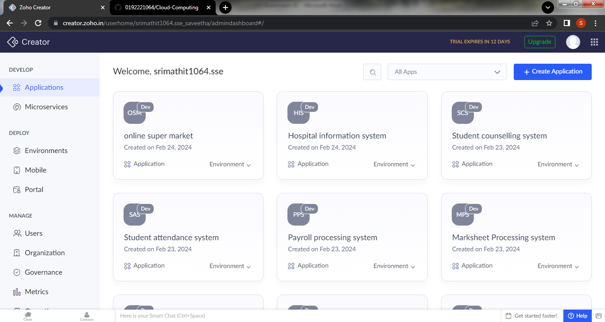

Step 6:create a new form for login details

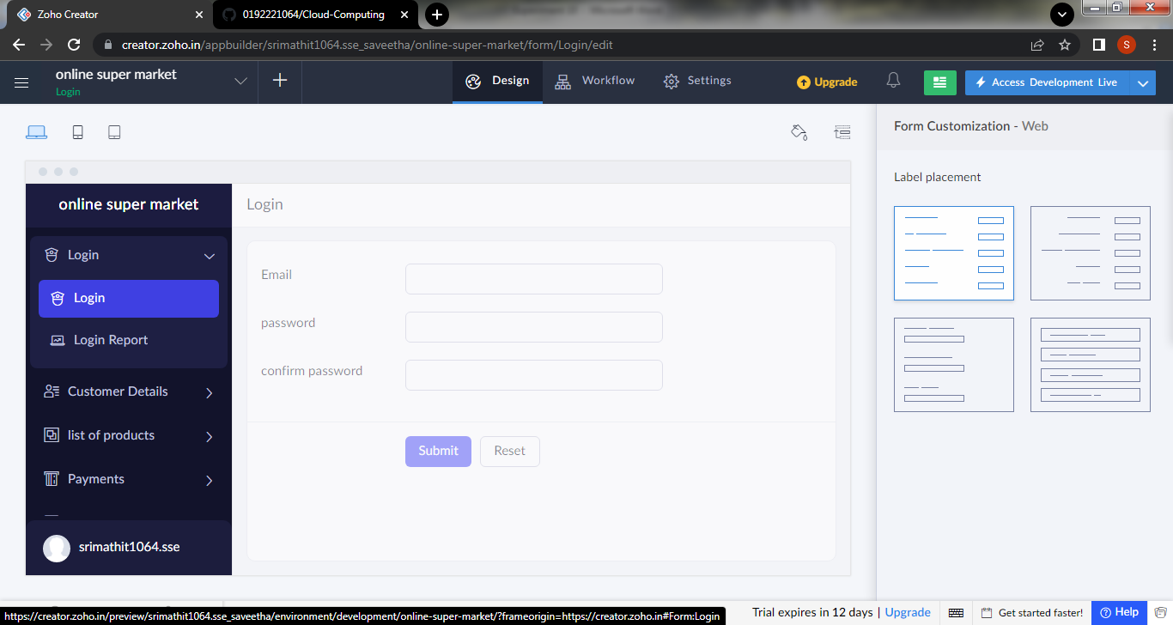

Step 7: create a second form for to the customer details

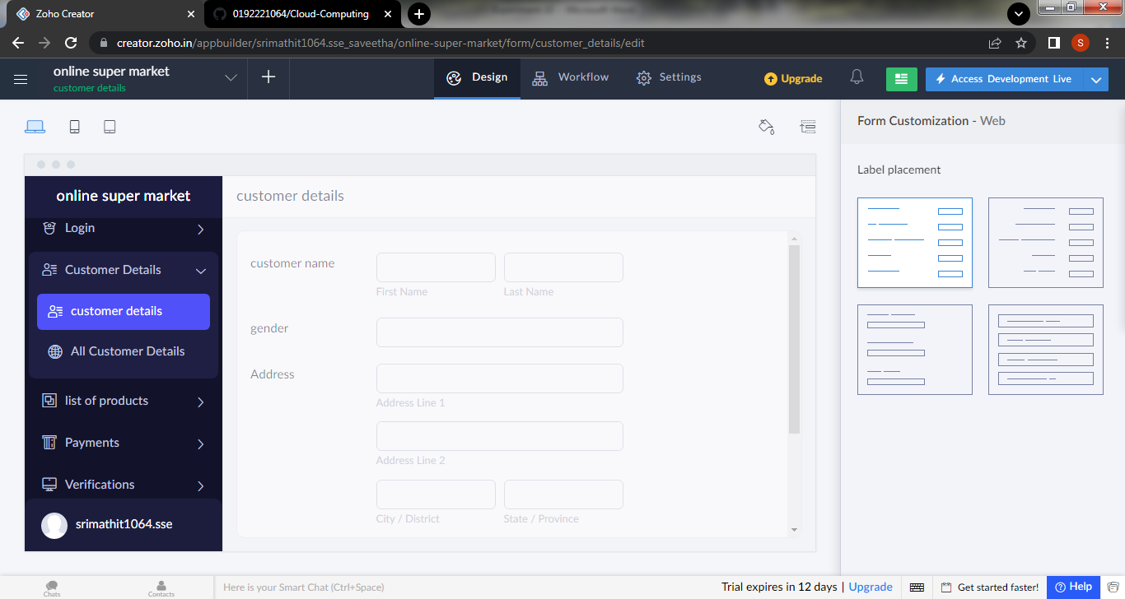

Step 8: Create a new form to view the list of the products available

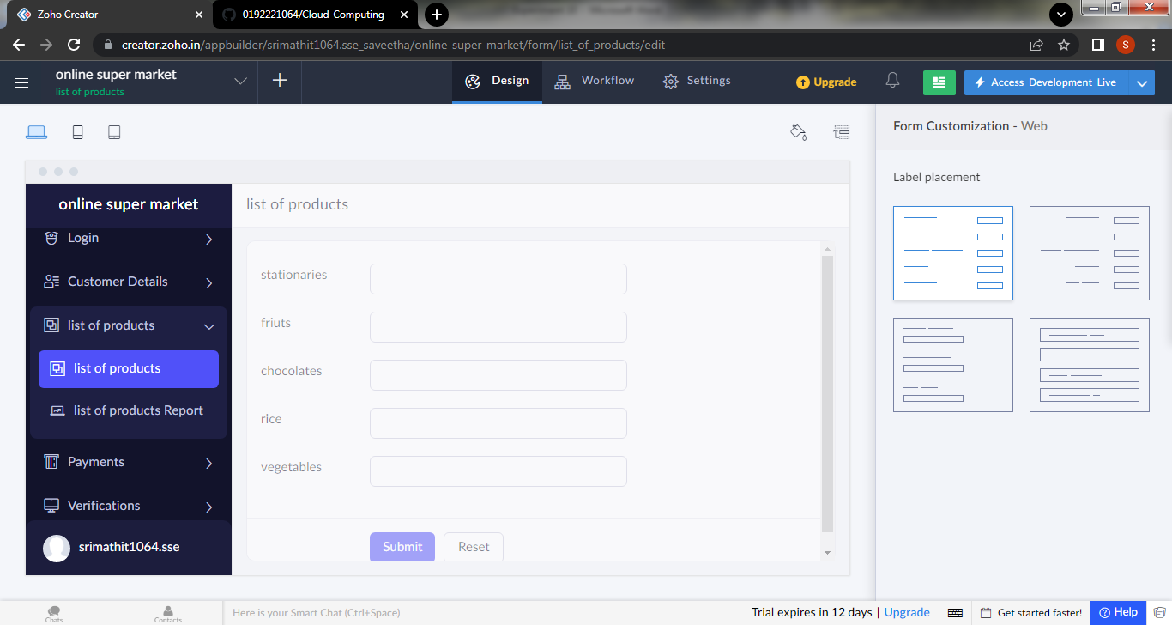

Step 9:create a form for payment

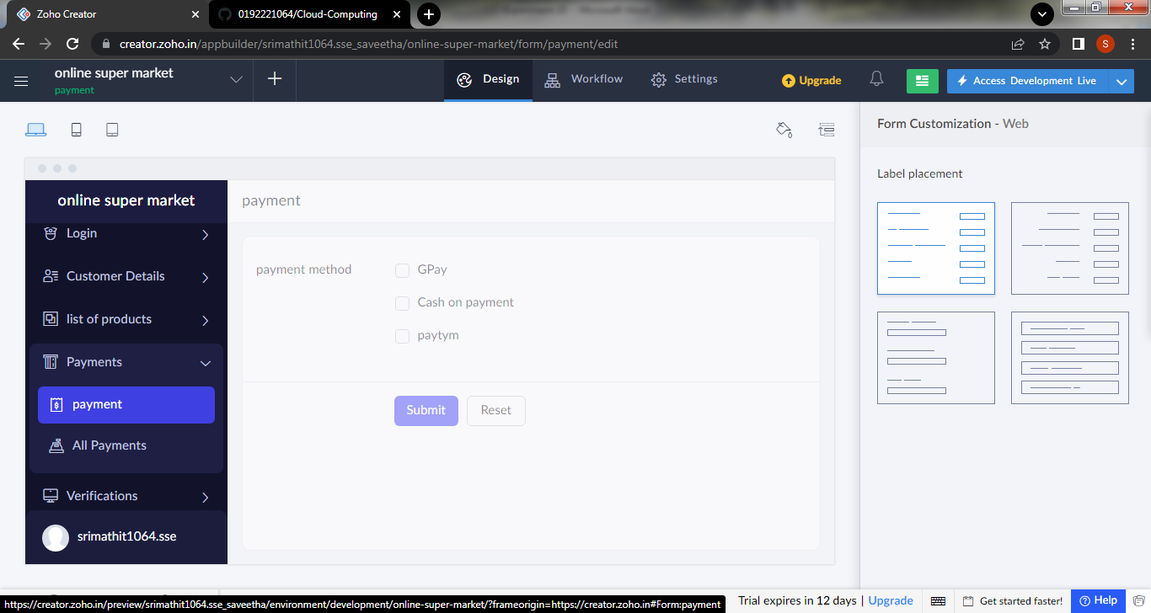

Step 10: create a new form for the verification of payment

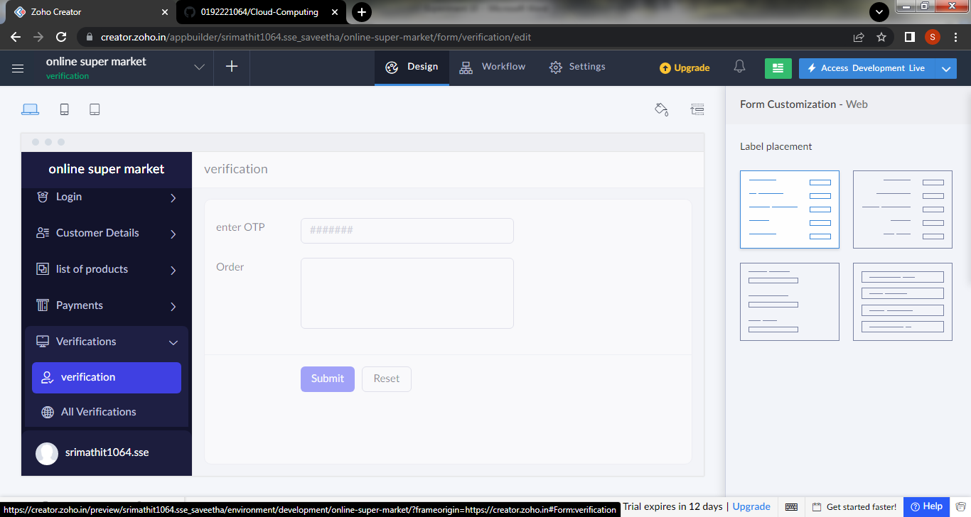

Step 11: click the access development to view the live output

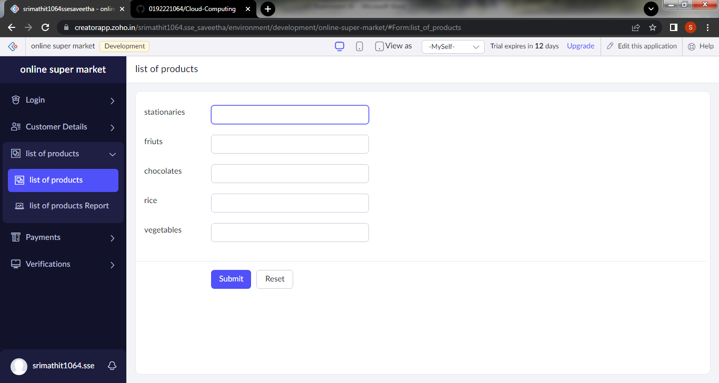

Step 12: click the report icon to view the data that are added

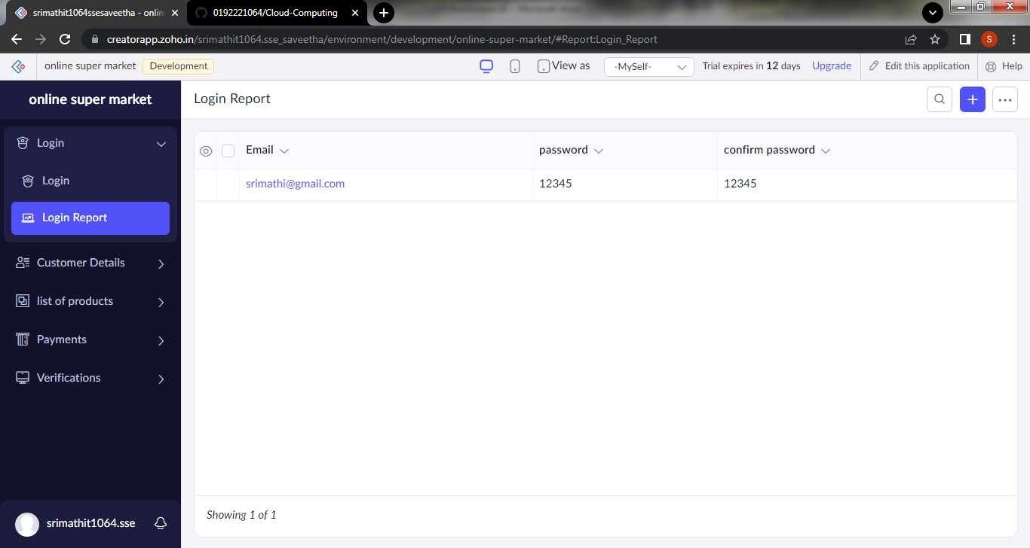

Step 13:click the mobile icon to view the output in mobile form

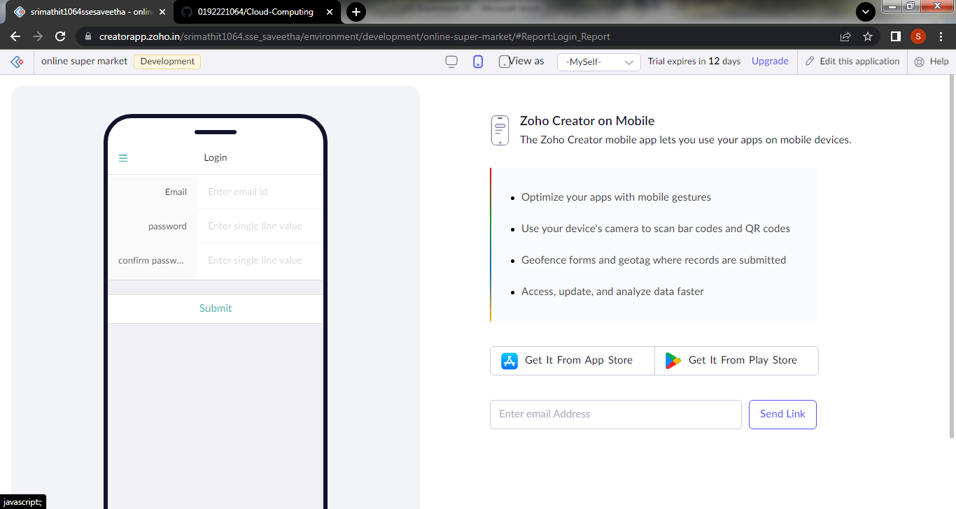

Step 14: click the tablet icon to view the output in tablet form

